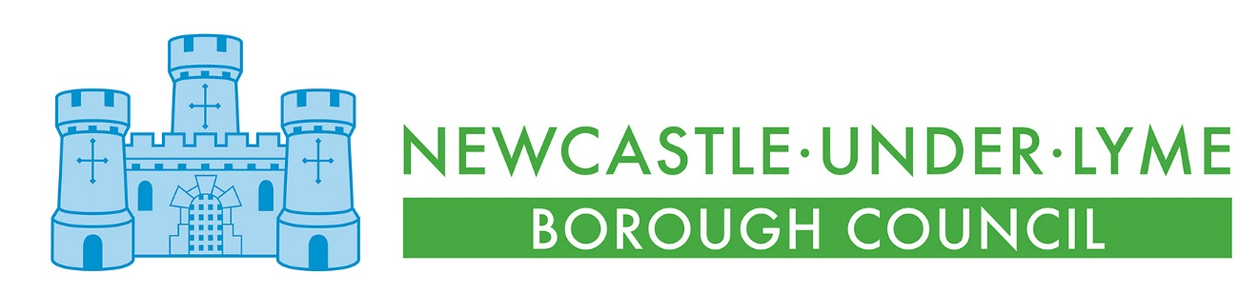
Newcastle Bereavement Services Price List
1 April 2026 to 31 March 2027

There is a premium for non-residents of the Borough of Newcastle-under-Lyme on Interment Fees and the Purchase of Exclusive Rights of Burial and Memorialisation Fees in the cemeteries and at the crematorium

NEWCASTLE CEMETERIES
Interment Fees | RESIDENT | NON-RESIDENT
Seventeen years of age and under (claimed by NULBC from the CFF) | £1200 | £1800
Eighteen years and over – coffin interment at 4’ 6” or 5’ | £1200 | £1800
Eighteen years and over – coffin interment at 6’ or 7’ | £1420 | £2130
Eighteen years and over – cremated remains interment at 2’ | £535 | £802.50
Woodland – coffin interment (Keele Cemetery only) | £1200 | £1800
Woodland – cremated remains interment at 2’ (Keele Cemetery only) | £535 | £802.50
Interment of body part | £535 | £802.50
Double interment – two interments taking place at the same time (cremated remains and coffin) | Interment fee + 50% | Interment fee + 50%
Additional depth for cremated remains interment – over 2’ | £280 | £290
Additional depth for cremated remains or a coffin interment – over 6’ per foot | £300 | £310
Exhumation fee – cremated remains | £1680
Exhumation fee – coffin | £3880
Purchase of Exclusive Rights of Burial and Memorialisation | RESIDENT | NON-RESIDENT
Lawn Grave – two coffin interments & cremated remains interments | £1610 | £3220
Reservation of Lawn Grave | £2260 | £3870
Cremated Remains Grave – up to four cremated remains interments | £810 | £1620
Reservation of Cremated Remains Grave | £1135 | £1945
Woodland Grave – one coffin interment with a memorial tree (Keele Cemetery only) | £1610 | £3220
Reservation of Woodland Grave | £2260 | £3870
Woodland Cremated Remains Grave – up to four cremated remains interments with a memorial shrub (Keele Cemetery only) | £810 | £1620
Reservation of Woodland Cremated Remains Grave | £1135 | £1945
Transfer of Ownership of the Exclusive Rights of Burial and Memorialisation | £130 | £183.80
Duplicate Deed of Exclusive Right of Burial and Memorialisation | £70 | £105
Renewal of Exclusive Right of Burial and Memorialisation – Lawn Grave | £495 | £1033.30
Renewal of Exclusive Right of Burial and Memorialisation – Cremated Remains Grave | £275 | £593.30
Erection of Memorials Fees
New memorial – prior to April 1990 the Right to erect a memorial was not included in the grave purchase fee | £200
Memorial Permit | £70
Columbarium Fees
10 year lease of a Columbarium including the first interment of cremated remains | £715
Second interment of cremated remains in a Columbarium | £110
Renewal of 10 year lease of a Columbarium | £350
Additional 5 year lease | £350
Use of Chapel and Community Room
Keele Community Room – funeral/memorial service | £252
Per hour hire | £31.50
Cemetery Sundry Items
Single abstract of information from the burial registers | £37
Family history research – hire of family history room 9:00am to 12:00pm | £27
Oak cremated remains casket – single casket with plaque | £105
Oak cremated remains casket – double casket with plaque | £133
Cremated remains casket plaque only | £17
Wooden cross/grave marker | £70
Memorial bench | £1638
Memorial tree | £465
Replacement vehicle access permit | £18.50
Late arrival of Funeral Director – issued to and to be paid by the Funeral Director | £220
Late paperwork | £60
Incorrect coffin size on paperwork | £60
Late removal of memorial resulting in a delay of grave excavation | £170
Administration fee | £95

