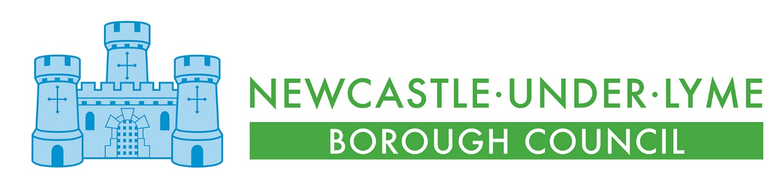
Newcastle Bereavement Services Price List
1 April 2026 to 31 March 2027

There is a premium for non-residents of the Borough of Newcastle-under-Lyme on Interment Fees and the Purchase of Exclusive Rights of Burial and Memorialisation Fees in the cemeteries and at the crematorium

NEWCASTLE (BRADWELL) CREMATORIUM
Cremation Fees
Direct Cremation Fee – Unattended by Family or Officiant  Available Monday to Thursday, before 9:00am  Medical Referee fees  Cremation administration, registration and operation  Cremation Certificate  Storage of ashes until collection and ashes container  Burial of ashes within a Garden of Remembrance  Environmental charge of £85 (inclusive) | £389.30
Cremation fee – 17 years of age and under  Claimed by NULBC from the CFF  40 minute service including the entrance and exit of mourners  Obitus music & Halo photo only  Medical Referee fees  Cremation administration, registration and operation  Cremation Certificate  Storage of ashes until collection and ashes container  Burial of ashes within a Garden of Remembrance  Environmental charge of £85 (inclusive) | £990
Early Cremation fee – 18 years of age and over  9:20am service time only  40 minute service including the entrance and exit of mourners  Obitus music & Halo photo only  Medical Referee fees  Cremation administration, registration and operation  Cremation Certificate  Storage of ashes until collection and ashes container  Burial of ashes within a Garden of Remembrance  Environmental charge of £85 (inclusive) | £745
Standard Cremation fee – 18 years of age and over  10.00am and onwards service times  40 minute service including the entrance and exit of mourners  Obitus music & Halo photo only  Medical Referee fees  Cremation administration, registration and operation  Cremation Certificate  Storage of ashes until collection and ashes container  Burial of ashes within a Garden of Remembrance  Environmental charge of £85 (inclusive) | £990
Columbarium Fees
10 year lease of a Columbarium including the first interment of cremated remains | £715
Second interment of cremated remains in a Columbarium | £110
Renewal of 10 year lease of a Columbarium | £350
Additional 5 year lease | £350
Interment Fees | RESIDENT | NON-RESIDENT
Interment of cremated remains in a Garden of Remembrance where the cremation took place elsewhere | £290
Interment of cremated remains in a cremated remains grave – 18 years of age and over | £535 | £802.50
Double interment – two interments taking place at the same time | Interment fee + 50% | Interment fee + 50%
Purchase of Exclusive Rights of Burial and Memorialisation | RESIDENT | NON-RESIDENT
Cremated Remains Grave – up to four cremated remains interments | £810 | £1620
Reservation of Cremated Remains Grave | £1135 | £1945
Transfer of Ownership of the Exclusive Rights of Burial and Memorialisation | £130 | £183.80
Duplicate Deed of Exclusive Right of Burial and Memorialisation | £70 | £105
Renewal of Exclusive Right of Burial and Memorialisation | £275 | £593.30
Memorial Permit | £70
Crematorium Sundry Items
Single abstract of information from the cremation registers | £37
Oak cremated remains casket – single casket with plaque | £105
Oak cremated remains casket – double casket with plaque | £133
Cremated remains casket plaque only | £17
Wooden cross/grave marker | £70
Postage and packaging | COST + £40
Late arrival of Funeral Director – issued to and to be paid by the Funeral Director | £220
Service overrun – issued to and to be paid by the Funeral Director | £220
Late paperwork | £60
Incorrect coffin size on paperwork | £60
Storage of ashes where burial is to arranged (per week after 12 weeks) | £23
Temporary deposit of ashes (per week after the first 4 weeks) | £23
Administration fee | £95
Copy of cremation certificate | £10
Exhumation fee | £1680
Use of Crematorium Chapel
Newcastle Crematorium Chapel – service only | £530
Additional service time charge – double time slot for a cremation service | £275

